Business Case RxFlow
Introduction
Business Case Conceptual Structure | Definitions
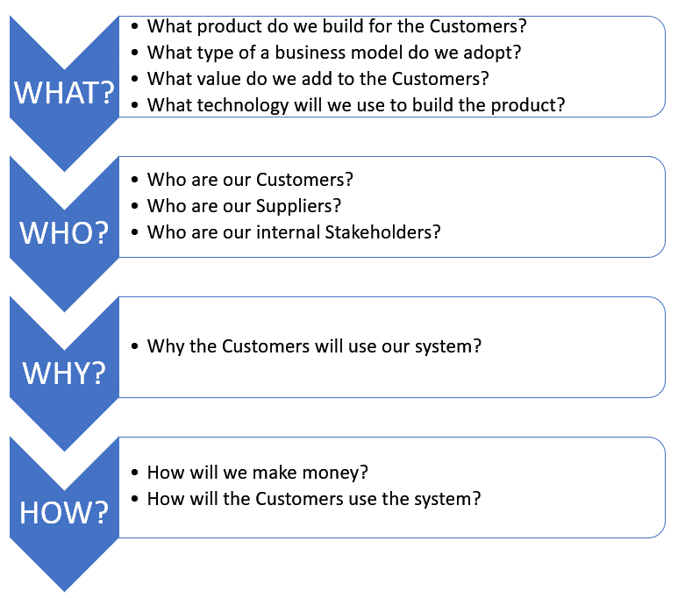 | Customer:  A customer is an individual or business that purchases another company's goods or services.  Customers are important because they drive revenues; without them, businesses cannot continue to exist.  Supplier:  A supplier is a person, business, or entity that provides products, data or services to another entity.  Stakeholder:  A person with an interest or concern in something, especially a business.  Stakeholders encompass all individuals or groups who have a vested interest in the performance of the business.  Note, the application team is a Delivery Team, not Stakeholder.  Business Model:  The term business model refers to a company's plan for making a profit. Examples: Freemium, Subscription, Advertising, etc.  Distribution Channel:  A distribution channel is a path that a product or service could take on its way to market. What's a direct distribution channel? A direct distribution channel is one where a company sells directly to the consumer, usually through their website or retail store.

Team No: 2
Application Name: RxFlow
Business case should be documented by completing the table below (Answers column).
Category | BC Section | Questions | Answers
WHAT? | Product Overview | Give a brief description of the proposed software product. | RxFlow is a B2B SaaS web application for independent and community pharmacies. It manages the end-to-end prescription workflow (intake → processing → ready → pickup), patient and prescriber records, and inventory (lot/expiry monitoring and low-stock alerts). RxFlow also connects to external systems for a drug data feed and a transaction exchange simulation, enabling realistic interoperability while keeping implementation risk low.
 | Value Propositions | What Customer business needs are we satisfying? | - Faster workflow: visible prescription queues reduce delays and missed steps.  - Inventory control: lot/expiry tracking reduces waste; low-stock alerts reduce stockouts.  - Accountability: role-based access + audit logs provide traceability (“who did what, when”).  - Data centralization: one searchable system for patient, prescriber, prescription, and drug data.  - Interoperability practice: integrations demonstrate real data exchange with external systems.
 |  | What value do we add to the Customers? | - Time Savings: Streamlined queues (New → Ready) allow technicians to process more scripts per hour.  - Cost Reduction: Prevents revenue loss from expired drugs or over-ordering inventory.  - Patient Safety: Reduces medication errors through structured validation and clear status tracking.  - Modern Accessibility: Unlike legacy desktop-bound systems, RxFlow is a modern web application that enables easier deployment and updates.
 | Type of Business Model | What type of a business model do we adopt? | - SaaS (Software as a Service) Subscription Model  - Revenue Stream: Recurring monthly or annual subscription fees charged per pharmacy location and/or per user seat.  - Scalability: The model supports "tiered add-ons" (e.g., premium analytics or additional integrations) to increase Customer Lifetime Value (CLV).  - Advertising-Supported Model  - Approved drug manufacturers, wholesalers, or pharmacy service vendors can advertise products and services within the platform (e.g., dashboards, notifications, or catalog placements), similar to portals such as PrimeRx.
 | Key Resources | What Key Resources do our value propositions require? | - Software Development Team: Engineers to build and maintain the 3-tier web architecture (GUI, API, Database).  - Reliable Cloud Infrastructure: Hosting services (e.g., AWS, Azure) to ensure high availability and security for client data.  - External Data Integrations: Stable connections to openFDA (for the Drug Catalog) and FHIR servers (for e-prescribing simulation) are critical for the system's core functionality.  - Industry Knowledge Base: Access to pharmacy workflow standards (reference systems like BestRx) to ensure the software matches real-world operational flows.
 |  | What are our Distribution Channels? | The business model is a "SaaS subscription model", implying that the software is distributed and accessed directly over the internet rather than installed via physical media or third-party app stores.
 | Technology | What technology will we use to build the product? | Front-end technology: React.js  Back-end technology: NodeJS  Database: PostgreSQL
 |  | Is it a mobile or Web/desktop application? | It is a Web application.
 | Known Prototypes | What are the know prototypes of your product?  Reference some known portals on the Internet that are similar to your product. You will use these prototypes for developing business, user requirements. | List of Prototypes:  - BestRx  - PioneerRx  - Liberty Software  - PrimeRx
WHO? | External Customers | Who are our Customers? | The primary customers are Independent and Community Pharmacies.  - The Buyer: The Pharmacy Owner or Manager who purchases the software subscription.  - The End-Users:  - Pharmacy Technicians: Perform data entry, queue processing, and inventory updates.  - Pharmacists: Perform clinical verification, approvals, and overrides.  - Pharmacy Administrators: Configure the system and pull reports.  Note: While the users are the staff members, the customer is the pharmacy business entity paying the monthly SaaS subscription.
 | External Suppliers | Who are our Suppliers?  Does the system exchange data with external systems? For example, banks, delivery contractors, restaurants, etc. | Suppliers are external systems that provide required data/services:  - openFDA: provides drug/NDC catalog data for importing drug records.  - HAPI FHIR: provides a test transaction endpoint to simulate incoming e-prescriptions (MedicationRequest resources).  - Payment Gateway / Credit Card Vendors (e.g., Stripe, Visa, Mastercard): Provide secure payment processing services for pharmacy subscription fees and transaction payments related to drug purchases.  - Optional supplier (if implemented): cloud hosting provider for system availability and backups.  Yes, RxFlow exchanges data with external systems:  - Data feed: pull drug information into the RxFlow database.  - Transaction exchange (test): pull/push test eRx transactions to demonstrate interoperability.
 | Internal Stakeholders | Who are our internal Stakeholders?  Do we need a product development group?  Do we need a sales group?  Do we need a finance group (accounts payable, receivable)?  Do we need a customer support team?  Do we need an advertising management group? | Internal stakeholders are individuals or groups within the organization who have a direct interest in the business performance and outcomes of RxFlow.  • Business Owners / Founders: Responsible for strategic direction, investment decisions, and long-term growth of the RxFlow platform.  • Product Management: Responsible for defining product vision, roadmap, and ensuring alignment with customer and market needs.  • Sales Management: Responsible for acquiring pharmacy customers, managing subscriptions, and driving platform revenue.  • Finance Team: Responsible for billing, accounts payable and receivable, revenue tracking, and financial reporting.  • Customer Support Management: Responsible for customer onboarding, issue resolution, and ongoing customer satisfaction.  • Advertising and Partnership Management: Responsible for managing vendor relationships, approving advertising content, and ensuring compliance within the platform.
WHY? | Expected Benefits to the Customer | Why do we believe our new product will be better than those already existing on the market? | Customers would choose RxFlow because it improves daily operations with:  - Clear workflow visibility: queue-based status tracking reduces bottlenecks and missed prescriptions.  - Reduced inventory waste: lot/expiry and low-stock monitoring prevent expired stock and emergency ordering.  - Simpler deployment: SaaS web delivery reduces the burden of installing and updating compared to legacy systems.  - Accountability: audit logs and role-based controls support operational traceability and safer processes.  - Interoperability: integrates external data feeds and transaction exchange simulations to reduce manual entry and demonstrate modern integration readiness.
 |  | Why the Customers would want to use our system? | The adoption of RxFlow is driven by the necessity for high-availability operational management and rigorous auditability in a pharmacy setting.  - Inventory Optimization and Heuristics: The system resolves inventory failures such as stockouts and waste through granular inventory tracking. By implementing a data model that tracks specific inventory lots and expiration dates, the system provides real-time visibility into on-hand levels, allowing for the algorithmic generation of reorder lists.  - Workflow Determinism: RxFlow uses a finite-state machine approach to prescription management, enforcing a strict transition logic that starts at New, progresses to In Process, then to Ready, and concludes at Picked Up. This allows stakeholders to filter queues by status or patient, optimizing throughput and task allocation.  - Non-Repudiation and Auditability: To satisfy accountability requirements, the system implements comprehensive dispensing event logging. The architecture includes a dedicated Audit Log that records the User ID, action type, entity ID, and timestamp for critical operations, ensuring a traceable history of exactly who performed specific actions and when they occurred.  Interoperability via API Integration: The system reduces manual data entry overhead by interfacing with external systems for data exchange. Specifically, it integrates with the openFDA endpoint to normalize drug catalog data and connects to HAPI FHIR servers to simulate the ingestion of structured MedicationRequest resources, validating the system's capability to handle standard healthcare transaction exchanges
HOW? | System Use | How will the External Customers use the system?  What is the main system use scenario for the External Customers? | Registration and Account Access  - Pharmacy staff (Technicians, Pharmacists, Admins) log in using secure credentials.  - Access level is strictly limited by role (e.g., Technicians for entry, Pharmacists for verification).  Viewing Patient Profiles and Prescription Scope  - View and search for patient and prescriber records associated with the pharmacy.  - Review the "New" prescription queue to understand the immediate workload.  - Access drug reference information imported from external feeds (openFDA).  Processing Prescriptions and Monitoring Inventory  - Track prescriptions as they move through visible status milestones (New, In Process, Ready).  - Receive automatic alerts when inventory stock is low or expiring.  - View specific lot numbers and expiration dates to prevent waste.  Verification and Dispensing Approval  - The Pharmacist reviews and approves prescriptions to advance them to "Ready" status.  - Dispensing events are automatically recorded with timestamps and staff IDs for accountability.  - The system validates workflow transitions to prevent errors.  Viewing Reports and Operational Data  - View daily queue summaries and audit logs to track "who did what, when".  - Review detailed inventory reorder lists generated by the system.  - Monitor operational efficiency through dashboard activity reports.  Pickup and Receipt Management  - Mark prescriptions as "Picked Up" within the platform at the point of hand-off.  - Generate and provide receipts to patients upon completion.  - Update the final system status to close the workflow loop.  The main system use scenario for external customers in RxFlow centers on managing the end-to-end prescription lifecycle, maintaining accurate inventory, and ensuring operational accountability through a single, centralized web application. By providing visibility into workflow queues, stock levels, and dispensing events, RxFlow enables independent pharmacies to reduce manual errors, prevent stockouts, and deliver a faster, safer patient experience.
 |  | What is the main system use scenario for the Internal Users? | Here is the main system use scenario for the Internal Users (Pharmacy Technicians, Pharmacists, and Admins):  View Active Queues and Records  - Active prescription queues categorized by status (New, In Process, Ready)  - Searchable patient and prescriber profiles  - Real-time inventory levels and drug reference data  Manage Prescriptions and Patient Profiles  - Create new prescription records manually or import from the eRx Inbox  - Update patient demographics and allergy notes  - Manage prescriber contact information and NPIs  Process and Verify Prescriptions  - The technician initiates a fill request  - A new script is entered or selected from the "New" queue for processing.  - Staff records dispensing details  - Technician selects inventory: The specific drug lot number and expiration date are recorded.  - System updates stock: The inventory count is automatically decremented.  - Pharmacist reviews for verification  - Safety check: The pharmacist reviews the entered data against the original order.  - Approval to "Ready": The status is advanced, making it visible for pickup.  - Staff completes the transaction  - Mark as Picked Up: The system records the final handover and generates a receipt.  Manage Inventory and Reorders  - Monitoring on-hand levels and expiration dates to prevent waste  - Viewing automatically generated low-stock alerts  - Creating reorder lists based on system suggestions  Monitor Operational Performance and Logs  - Viewing daily queue summaries and activity reports  - Accessing detailed audit logs to track "who did what, when"  - Reviewing dispensing history for compliance  Configure Settings and Team Preferences  - Manage user accounts and role assignments (Tech vs. Pharmacist)  - Configure external data feed integrations (openFDA, FHIR)
 | Revenue Generation, Revenue Streams | How will we make money?  Such as Subscription fees, renting, leasing, licensing, brokerage fees, advertising sales, etc. | RxFlow generates revenue using a subscription-based Software-as-a-Service (SaaS) model tailored for independent and community pharmacies.  - RxFlow enables and supports the pharmacy’s primary revenue stream, which is the sale of prescription drugs to customers.  - Monthly subscription fees are based on the number of pharmacy locations and active users  - Tiered pricing plans that offer additional features such as advanced reporting, audit logs, and extended data integrations  - Optional add-on services include custom reports, enhanced system configuration, and extended data retention  - Advertising revenue where approved drug suppliers or vendors can promote products or services within the system  This model provides steady recurring revenue for the platform while supporting pharmacies in efficiently managing drug sales, keeping the system affordable and scalable for small pharmacy operations.

